(2) Antonio, Michele and Giovanni are members of the Italian Alpine Club

(CAI). Any member of the club who is not a skier is a climber. Climbers do

not like rain. Any person who does not love snow is not a skier. Antonio

does not love what Michele loves. Antonio loves rain and snow. Is there a

CAI member who is a skier but not a climber?

Rain and snow has nothing to do with Antonio Michele and Giovanni

Create two domains

* D1 for person (a,g,m)
* D2 for meteorological event (rain, snow)

Any member of the club who is not a skier is a climber

∀ xD1( ¬ S(x) → C(x)) specify the domain of x

Climbers do not like rain.

∀ xD1 (C(x) → ¬ L(x,r))

Any person who does not love snow is not a skier.

∀ xD1 ( ¬ L(x,s) → ¬ S(x))

Antonio does not love what Michele loves.

∀ xD2 ( L(m,x) → ¬ L(a,x))

Antonio loves rain and snow

L(a,r) ^ L(a,s)

THESIS: Is there a CAI member who is a skier but not a climber?

∃xD1( S(x) ^ ¬ C(x))

Negate:

∀ x( ¬ S(x) v C(x))

The Herbrand universe is formed by

D1: a,g,m

D2: r,s

We need to instantiate all universal sentences, namely

7) ¬ S(a) → C(a)

8) ¬ S(g) → C(g)

9) ¬ S(m) → C(m)

10) C(a) → ¬ L(a,r)

11) C(g) → ¬ L(g,r)

12) C(m) → ¬ L(m,r)

13) ¬ L(a,s) → ¬ S(a)

14) ¬ L(g,s) → ¬ S(g)

15) ¬ L(m,s) → ¬ S(m)

16) L(m,r) → ¬ L(a,r)

17) L(m,s) → ¬ L(a,s)

18) ¬ S(a) v C(a)

19) ¬ S(g) v C(g)

29) ¬ S(m) v C(m)

———————-

1. L(a,r)
2. L(a,s)

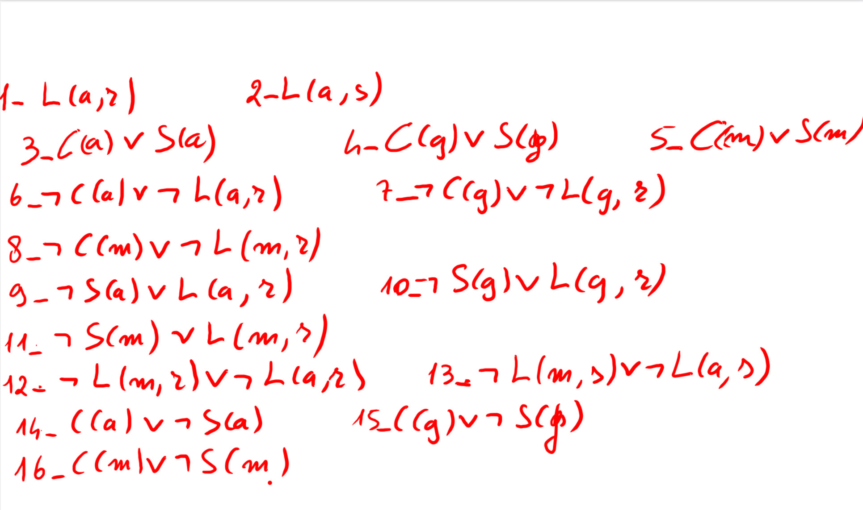

CDCL

Propagated

L(a,r) (1)

L(a,s) (2)

¬ C(a) (6)

S(a) (3)

C(a) v ¬ S(a) (14)

Is a conflict clause

Since we got conflict without decided literals, the answer is unsat